**Phys 11A - Eiteneer**

**Lab: Friction on an Inclined Plane**

**Online version**

**Names: ______________________________________________________________________________**

**Purpose**

To practice with drawing FBDs and working with net force; to learn to work with inclined planes and frictional forces.

**Introduction**

Newton’s Laws assert that if a particle is in equilibrium then the total force on it must vanish, i.e. the vector sum of the applied forces must be equal to zero, 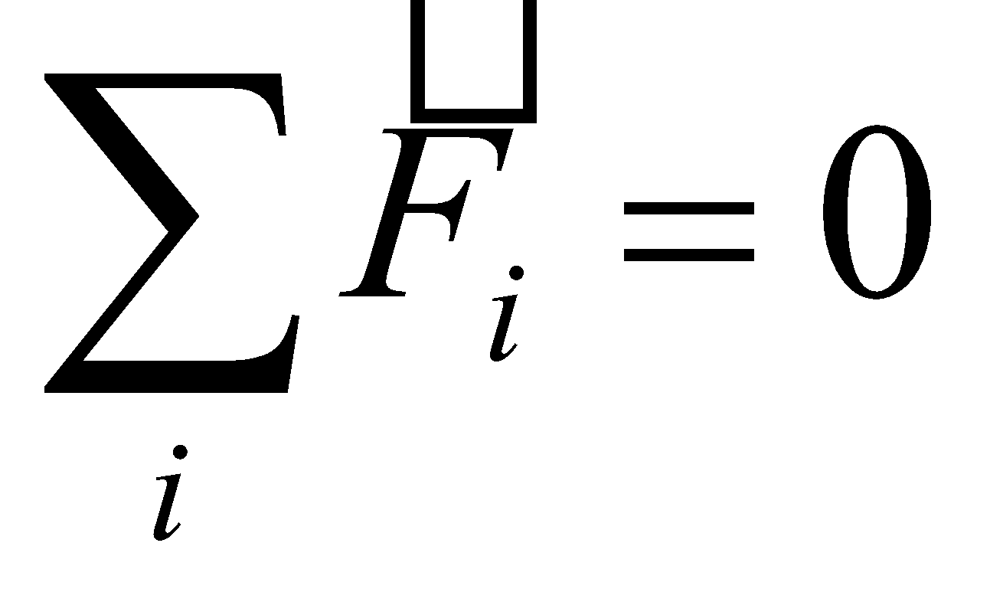. If the total force is not zero, the particle is not in equilibrium, and then 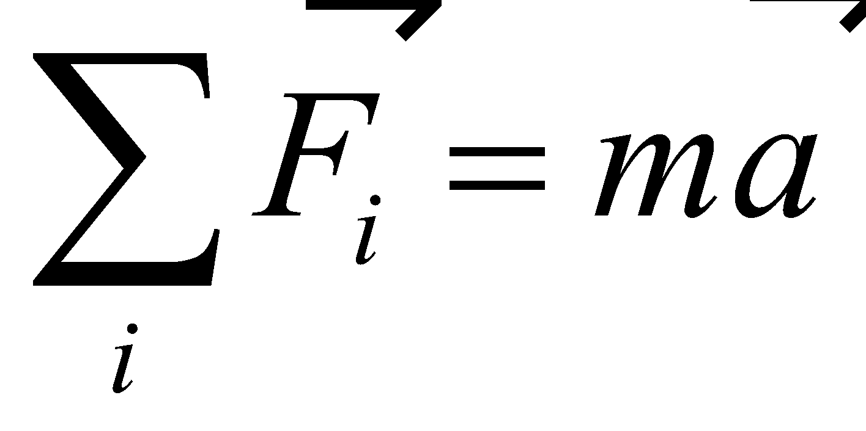.

The purpose of this experiment is to work with a system which can be in equilibrium, or not in equilibrium (what is the main difference and how can you tell?). We will also practice drawing FBD and working with friction.

**Prelab**

1. Below is a schematic of an inclined plane problem. In the space provided, draw a free-body diagram and label all the forces acting on the box. How can you tell if this box is in equilibrium or not?

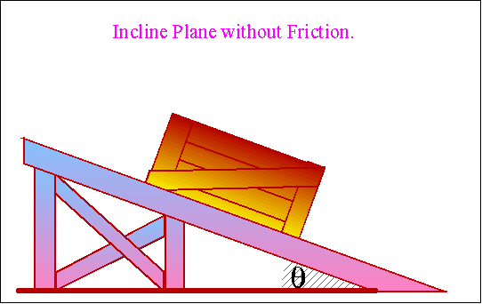

1. Is there a difference between drawing an FBD for a static case vs. kinetic case? Why or why not?

**Experimental Procedure & Data Analysis**

**Part I – Static case**

1. For this part of the experiment, an inclined plane (consisting of a “frictionless” track) as shown in the figure in the prelab was set up. The angle was adjusted such that it was **just** enough to keep the object from sliding. *Hint:* think static friction!
2. Measure the mass of the object and the angle (see “StaticAngle”). Don’t forget experimental uncertainties and units!

m = 111 g ± 1 g θ = ___________

1. Using the FBD you drew in the prelab, set up both  equations, and use them to derive the expression for the coefficient of static friction. Show all work! You may use additional sheet of paper if necessary.
2. You should’ve derived 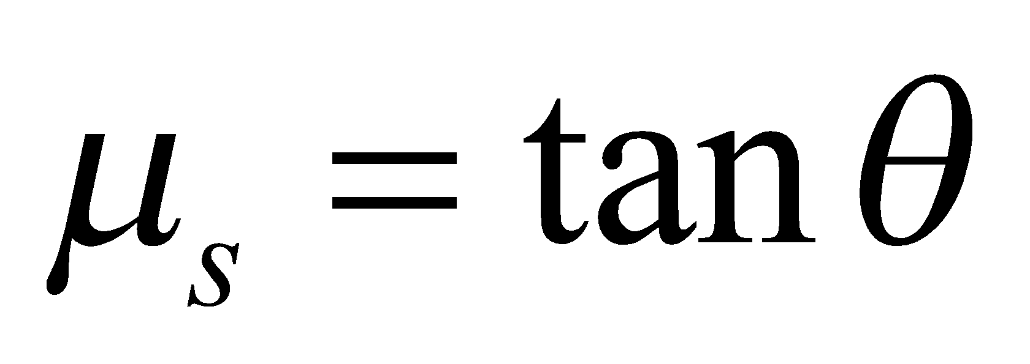. Using propagation of error analysis, derive the expression for uncertainty in *µs*.
3. In cases like this, *θ* can be expressed in degrees, but *δθ* **must** be in radians. Take your *δθ* from #2 above, convert it to radians, and use it to calculate *δµs*. Show all work!
4. Report your final value for µs±δµs: _______________________

**Part II – Kinetic case**

1. The angle is now increased, such that the object slides down the incline. *Hint:* think kinetic friction!
2. Measure the new value of the angle (see “KineticAngle”). Don’t forget experimental uncertainties and units!

θ = ___________________________

1. Measure the time (with uncertainty and units) it takes the object to slide down the incline (use the video “KineticMovie” – you may need to pause it to determine the exact length that the object slides and the time). Use “KineticInitialPosition” for initial position. It actually does not matter where the final position is, as long as you record the distance traveled and the corresponding time. Record both the time and position with uncertainty and units.

t = ___________________________ d = ___________________________

1. Calculate the acceleration of the object down the incline, using 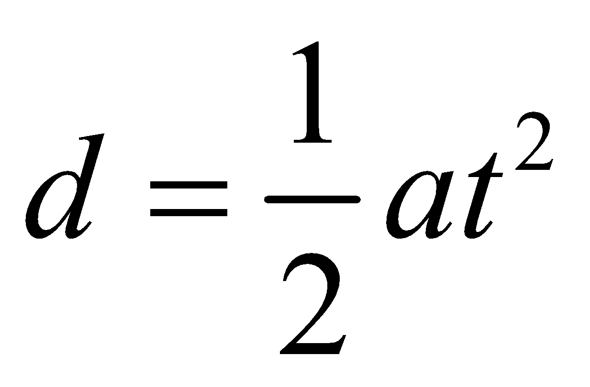.
2. Using propagation of error method, derive an expression for uncertainty in acceleration, *δa*.  
   Hint: *a = a(d,t).*
3. Using the equation you derived in the previous problem, calculate uncertainty in acceleration. Show your work! Make sure to keep track of units.
4. Using the FBD you drew in the prelab, set up both  equations, and use them to derive the expression for the coefficient of kinetic friction. Show all work! You may use additional sheet of paper if necessary (remember !).
5. You should’ve derived 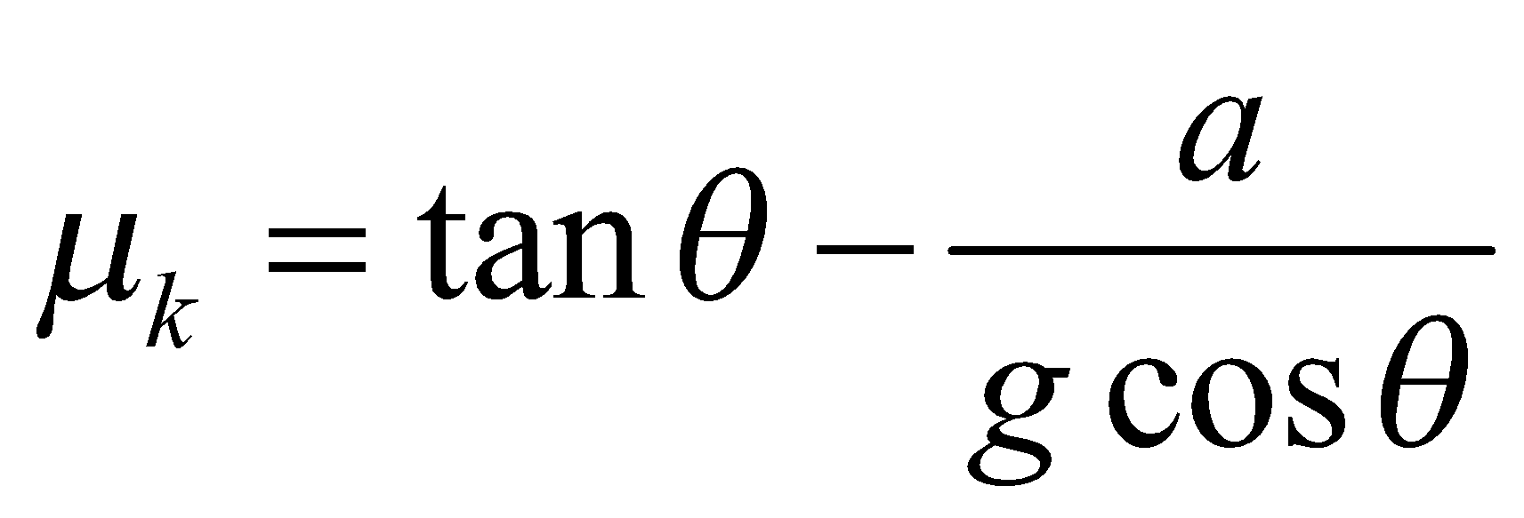. Using propagation of error analysis, derive the expression for the uncertainty in *µk*. Take *g* to be exact. Show all work!
6. Using your derivations in the previous two questions, calculate the coefficient of kinetic friction and the uncertainty *δµk*.
7. Report your final value for *µk±δµk*: _______________________
8. Did the  end up being smaller than the ? If not, what could be the reason? *Hint:* there is something about the **setup** of this experiment that usually the wrong result here. What is it? It is not obvious.
9. List all the errors that you can think of, in relation to this experiment, and classify them as systematic or random.
10. The coefficients of friction for felt on aluminum are 0.184 (kinetic) and 0.28 (static). Calculate the % error between the actual values and the values you obtained from the experiment.
11. What could be done differently to reduce percent error and to assure that 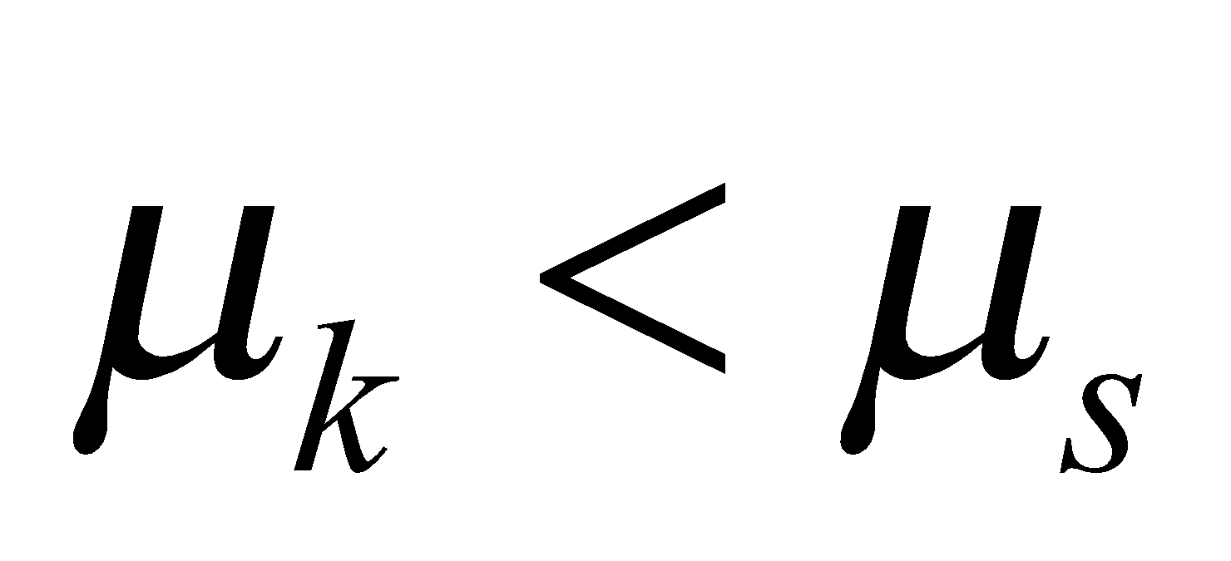?
12. What do you notice about the mass in all of your derivations/calculations? Why do you suppose this happens, physically/conceptually?